University of Missouri

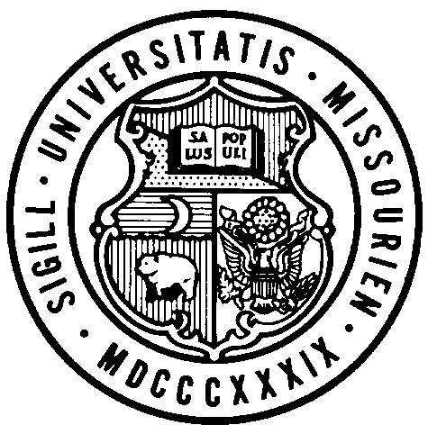
Board of Curators

Special Meeting

Tuesday, January 11, 2022
8:00 A.M.

Originating:
From remote locations via Zoom and/or conference telephone.

Zoom Webinar Link: https://umsystem.zoom.us/j/99197394966
Webinar ID: 99197394966

Public Session Dial-In Number: +13017158592,,99197394966#

AGENDA

PUBLIC SESSION – 8:00 A.M.

- Call to Order – Roll call of the Board of Curators
- General Business
  - Action
    - COVID-19 Protocols
    - Adjourn, Board of Curators Special Meeting, January 11, 2022

